Perform hands-on implementation in AWS.

AWS SQS (Simple Queue Service) - Amazon MQ - AWS Secrets Manager

1: AWS SQS — Simple Queue Service
Amazon SQS is a managed message queue that allows one application to send messages and another application to process them without needing to communicate directly at the same time.
Or
Amazon SQS provides queues for high-throughput, system-to-system messaging. You can use queues to decouple heavyweight processes and to buffer and batch work. Amazon SQS stores messages until microservices and serverless applications process them.
- In AWS:
Application A → SQS Queue → Application B
This is called decoupling.
- SQS: AWS's own queue service, simple and highly scalable.
AWS SQS — Implementation Steps
Step 1 — Open Amazon SQS
- Logged in to the AWS Management Console.
- Opened Amazon SQS from the AWS services menu.
- Selected the us-east-1 (N. Virginia) region.
Step 2 — Create an SQS Queue
- Clicked Create queue.
- Selected Standard as the queue type.
- Entered the queue name:
majeed-sqs-demo
- Kept the default configuration settings.
- Kept the default access policy.
- Left Dead-Letter Queue configuration disabled.
- Clicked Create queue.
Result: The queue majeed-sqs-demo was created successfully.
Step 3 — Send a Message
- Opened the majeed-sqs-demo queue.
- Clicked Send and receive messages.
- Entered the following message in the Message body:
Hello from Majeed SQS
- Kept the optional settings at their default values.
- Clicked Send message.
Result: The message was successfully sent to the SQS queue.
Step 4 — Receive the Message
- In the Receive messages section, clicked Poll for messages.
- SQS retrieved the available message from the queue.
- Opened the received message.
- Verified the message body:
Hello from Majeed SQS
Result: The message was successfully received and verified.
Step 5 — Delete the Message
- Returned to the Messages list.
- Selected the received message.
- Clicked Delete.
- Confirmed the deletion.
Result: The message was successfully deleted from the queue.
Step 6 — Final Verification
The complete SQS message flow was successfully tested:
Send → Queue → Receive → Verify → Delete
Observation
Amazon SQS provides a reliable way to decouple application components. A producer can send messages to the queue, while a consumer can retrieve and process those messages independently.
Final Status
AWS SQS Hands-on Implementation — COMPLETED

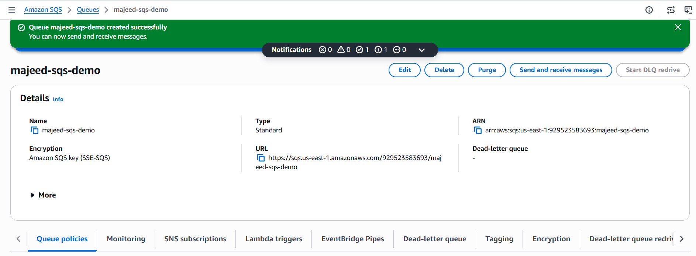
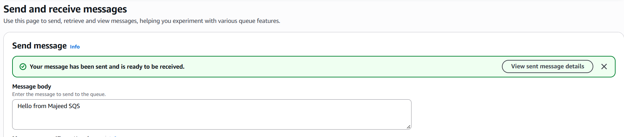
Received Message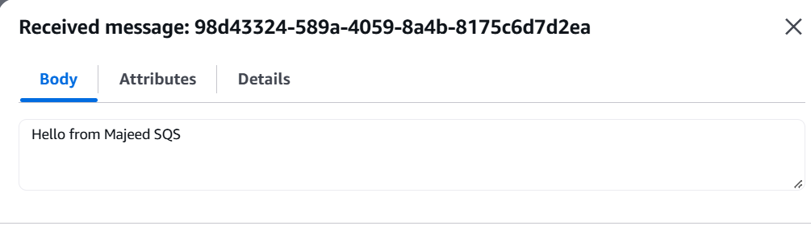
Deleted message
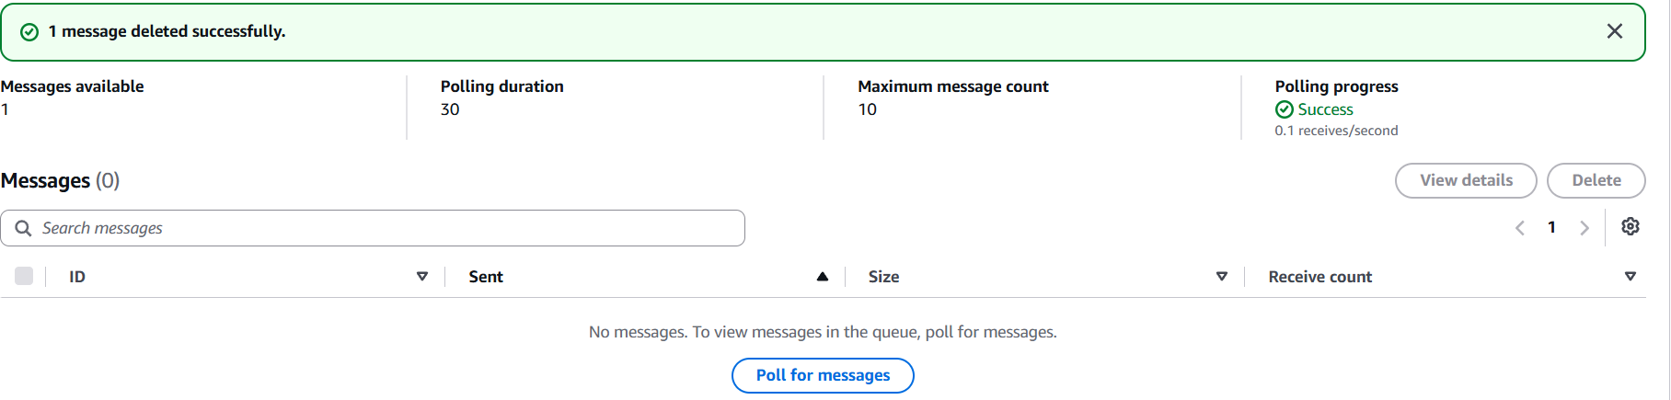
Architecture for SQS document

Application / Producer
|
| Send Message
↓
Amazon SQS Queue
majeed-sqs-demo
|
| Receive Message
↓
Application / Consumer
|
↓
Process Message

2: Amazon MQ
Amazon MQ is a fully managed AWS service that lets you run and use message brokers such as ActiveMQ and RabbitMQ without managing the broker infrastructure yourself.
Simple example
Imagine a company has different applications:
Application A → Message Broker → Application B
The message broker receives messages from one application and delivers them to another.
- Amazon MQ: Managed message broker, useful when applications already use traditional messaging protocols and broker features such as ActiveMQ or RabbitMQ.

Implementation / Steps:
- Opened Amazon MQ in the AWS Management Console and selected the us-east-1 (N. Virginia) region.
- Selected Create brokers and chose Single-instance broker deployment.
- Selected Apache ActiveMQ as the broker engine and ActiveMQ version 5.19.
- Selected Amazon EBS as the storage type.
- Created the broker with the name majeed-activemq-demo.
- Configured ActiveMQ authentication using Simple Authentication and Authorization.
- Created an ActiveMQ user with the username mqadmin.
- Configured the broker with:
  - VPC: majeed-vpc
  - Subnet: majeed-public-subnet
  - Security Group: default
  - Access Type: Public access
- Created the Amazon MQ broker and waited for the broker status to change from Creation in progress to Running.
- Opened the ActiveMQ Web Console using the Web Console URL provided in the broker details.
- Initially, the connection timed out because the security group did not allow inbound traffic on port 8162.
- Updated the security group's inbound rules and allowed Custom TCP port 8162 from My IP.
- Accessed the ActiveMQ Web Console successfully and logged in using the mqadmin user.
- Verified the ActiveMQ broker details:
- Broker Name: majeed-activemq-demo
- ActiveMQ Version: 5.19.7
- Broker Status: Running
- Deployment Mode: Single-instance broker
- Storage: Amazon EBS
Result:
Amazon MQ broker was successfully created, configured, and accessed through the Apache ActiveMQ Web Console.
Observation:
Amazon MQ is a managed message broker service that supports messaging brokers such as Apache ActiveMQ. It allows applications to communicate through a message broker without requiring the user to manage the underlying broker infrastructure.

Error while creating broker
Make changed by adding vpc’s

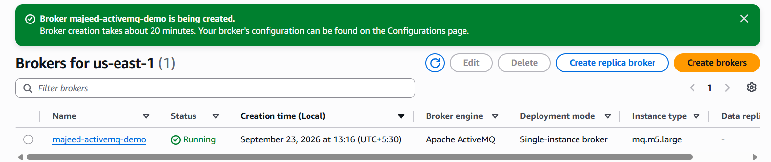

Error: The ActiveMQ Web Console uses TCP port 8162, so your connection is timing out.
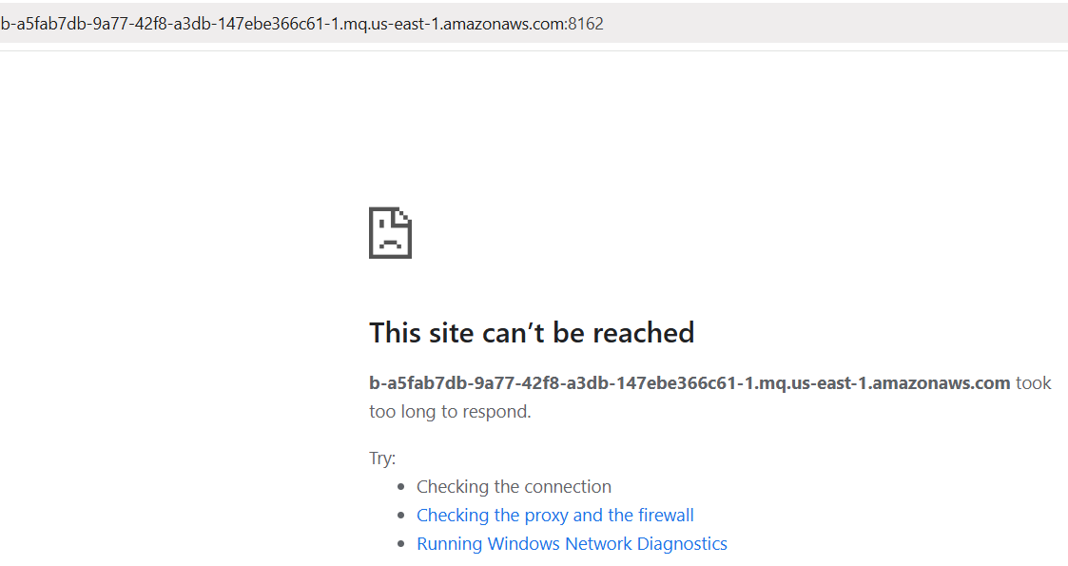
Resolve by adding
Click Edit inbound rules.
Then add a new rule:
- Type: Custom TCP
- Port: 8162
- Source: My IP
- Description: ActiveMQ Web Console
Using My IP is better for this lab than opening port 8162 to everyone.
Then click Save rules.
Open Amazon MQ and click:
ActiveMQ Web Console
In an active/standby deployment, only one of the ActiveMQ Web Console URLs is active at a time.
https://b-a5fab7db-9a77-42f8-a3db-147ebe366c61-1.mq.us-east-1.amazonaws.com:8162

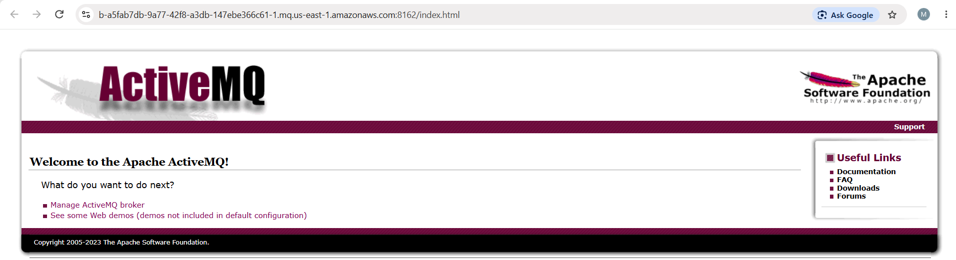

Click Manage ActiveMQ broker.
It should ask you to log in. Use:
- Username: mqadmin
- Password: your password
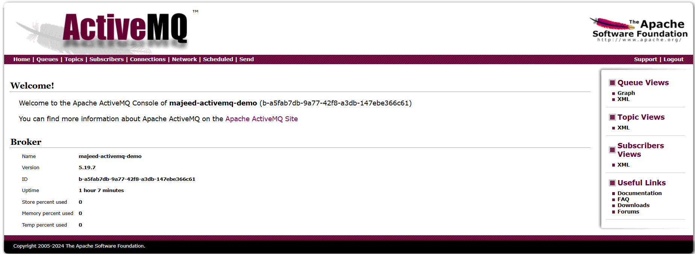

3: AWS Secrets Manager — Simple Definition
AWS Secrets Manager is an AWS service used to securely store, manage, and retrieve sensitive information such as:
- Database usernames and passwords
- API keys
- Application credentials
- Tokens
Instead of writing passwords directly inside application code or configuration files, the application can retrieve them securely from Secrets Manager.
AWS Secrets Manager is a managed service that securely stores, manages, and retrieves sensitive information such as passwords, API keys, and database credentials.

Implementation / Steps:
- Opened AWS Secrets Manager from the AWS Management Console and selected the us-east-1 (N. Virginia) region.
- Clicked Store a new secret.
- Selected Other type of secret to store custom key/value information.
- Created the following secret values:
  - Key: username
  - Value: majeed
  - Key: password
  - Value: Test password created for the lab
- Used the default AWS managed encryption key:
  - aws/secretsmanager
- Configured the secret:
  - Secret name: majeed-secret-demo
  - Description: Demo secret for AWS Secrets Manager hands-on
  - Tags: None
  - Resource permissions: None
  - Secret replication: Disabled
- Configured automatic rotation as Disabled because this was a basic hands-on demonstration and no rotation Lambda function was required.
- Reviewed the configuration. The console showed 0 Errors and 0 Warnings.
- Clicked Store to create the secret successfully.
- Opened the majeed-secret-demo secret from the Secrets Manager list.
- Clicked Retrieve secret value and verified that both the username and password values were successfully displayed.
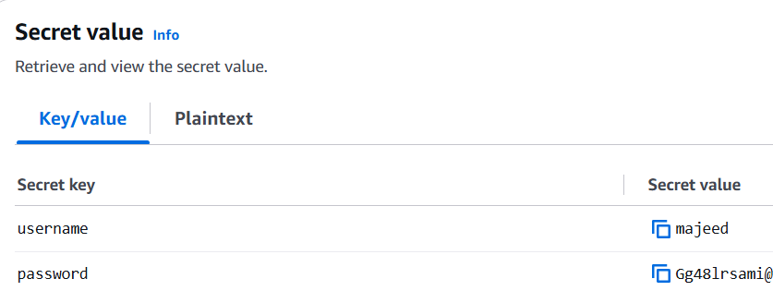

Result:
The AWS Secrets Manager secret was successfully created, configured, stored, and retrieved.
Observation:
AWS Secrets Manager provides a secure and centralized way to store and retrieve sensitive information such as database credentials, API keys, and application secrets instead of storing them directly in application code or configuration files.

